Programming 6212 Part 2
St 10456326
PROG6212-POE Part Two
YouTube link: https://youtu.be/6zhdynielk4
GitHub link: https://github.com/VCDN-2025/prog6212-poe-part-2-ad70000.git
  - Updated Views
Lecture View
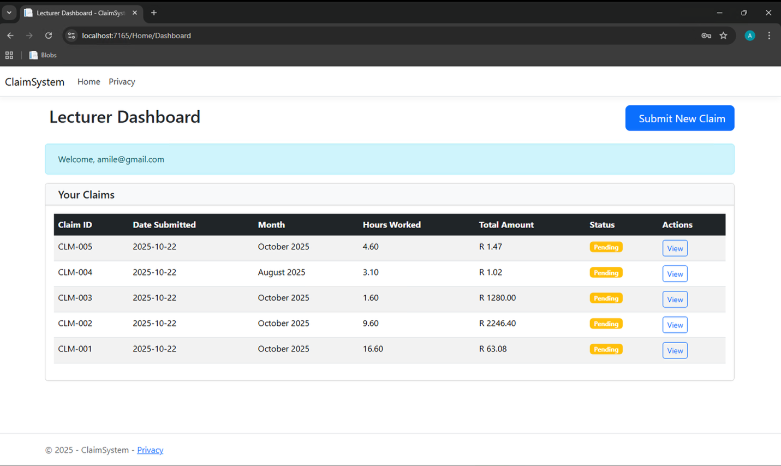

Program Coordinator
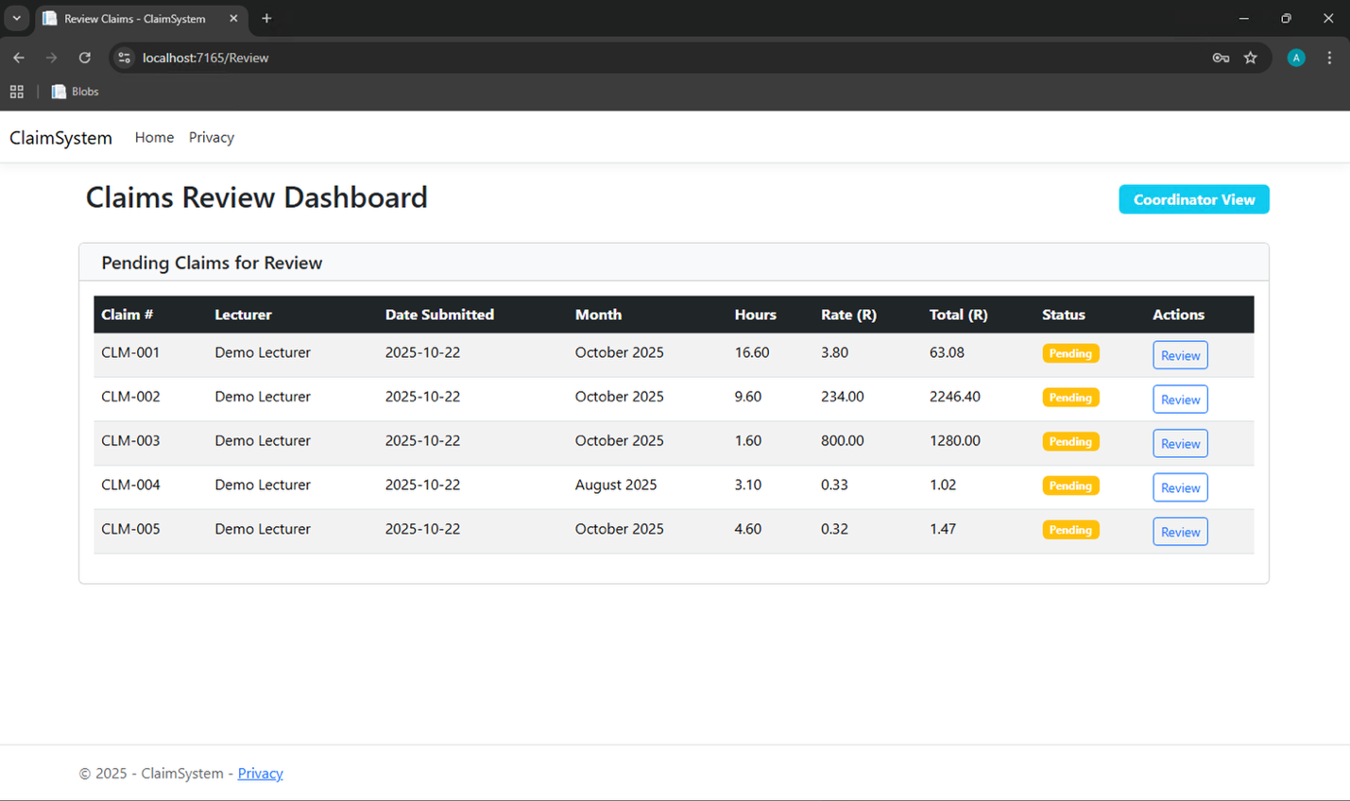

Manager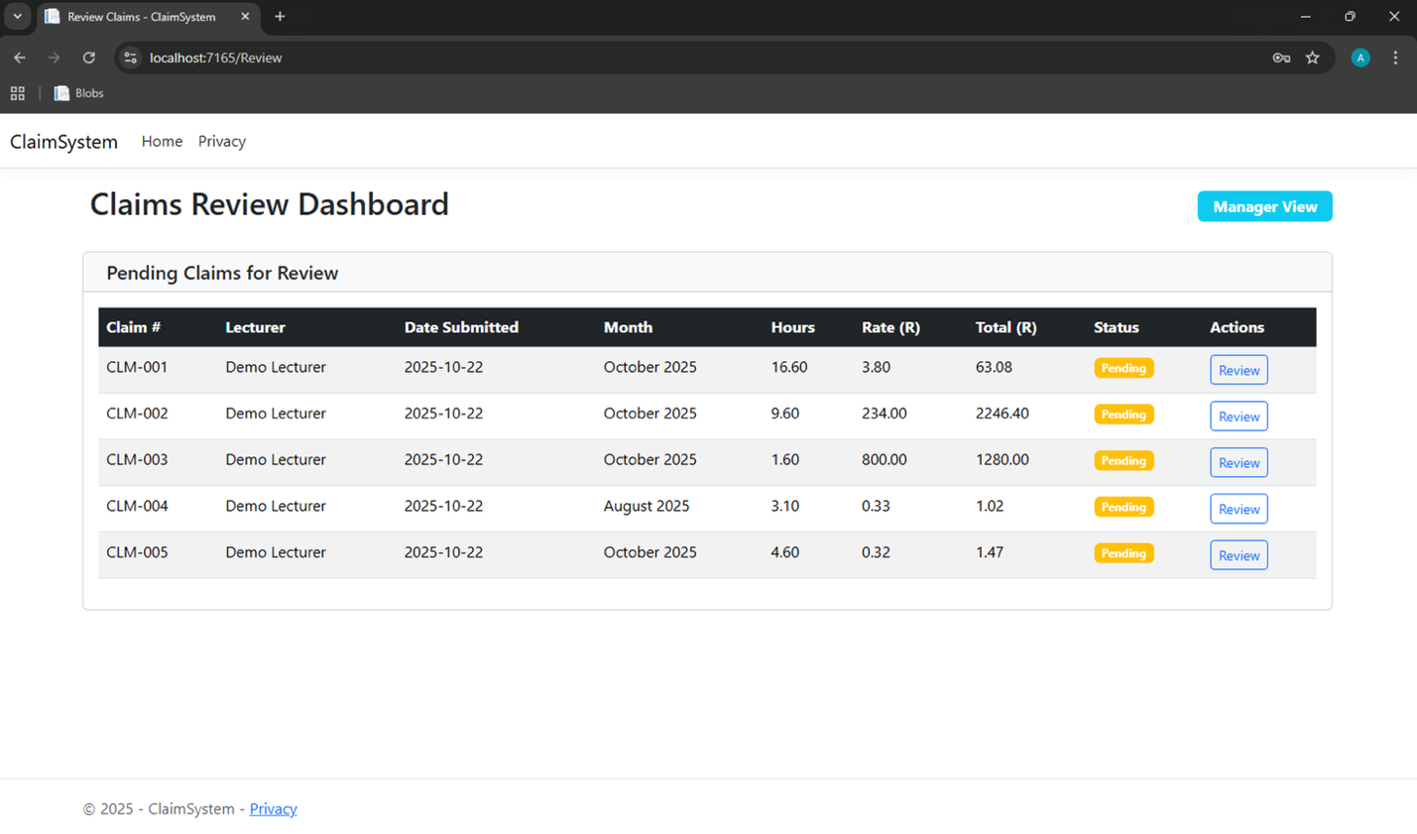

  - Database
  - 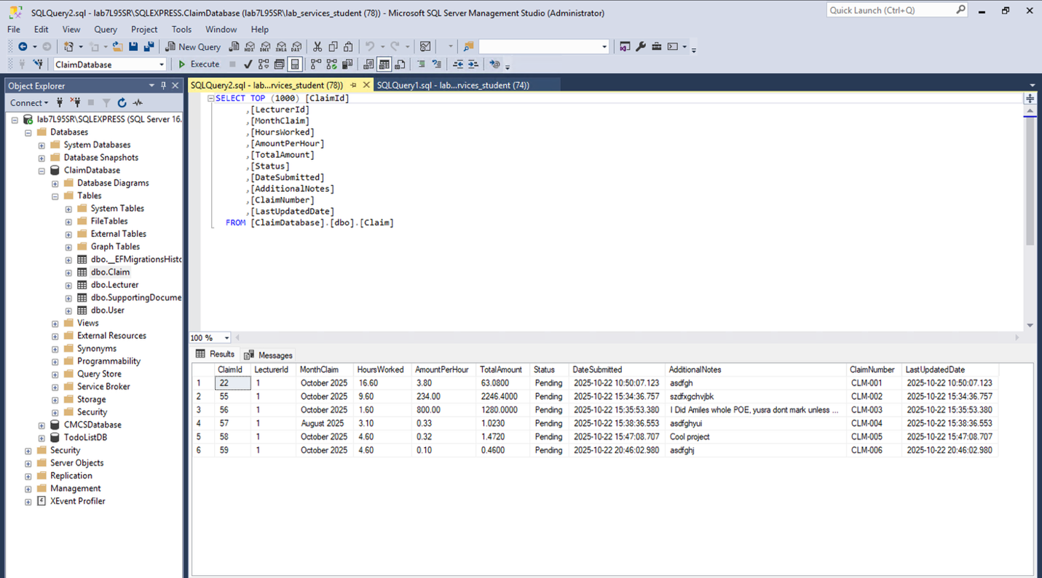

  - 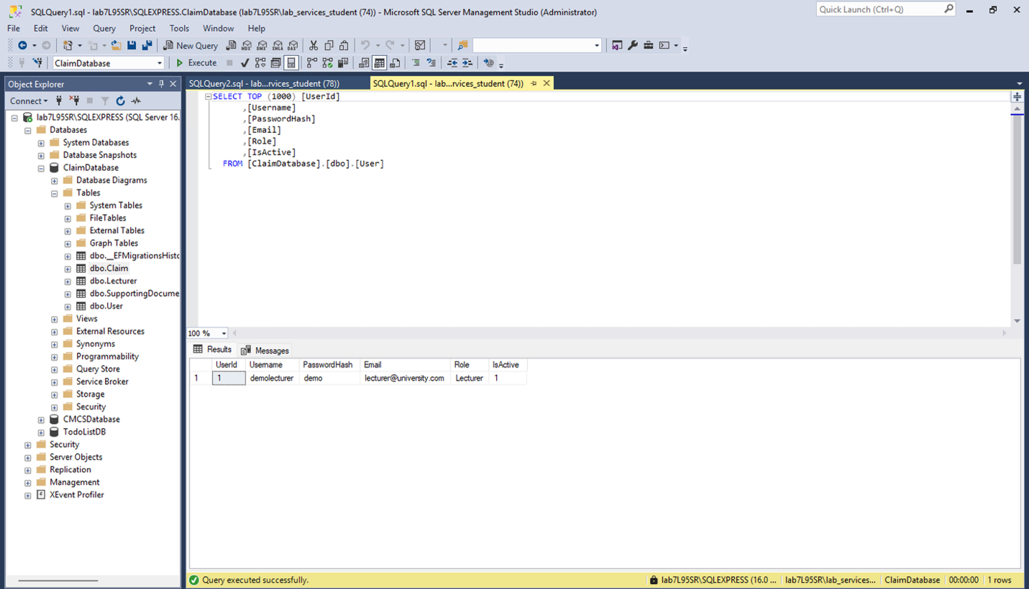

  - An example of the supporting document being saved
  - 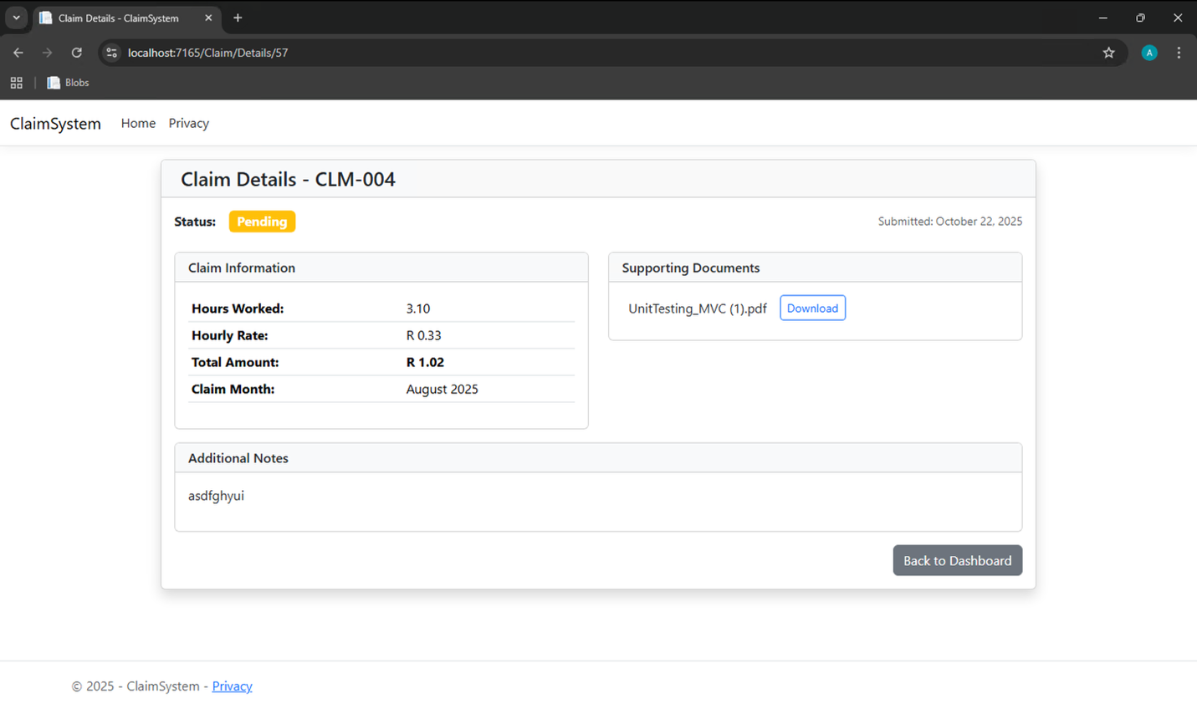

  - MS Project Test
Claim Controller Test

  - 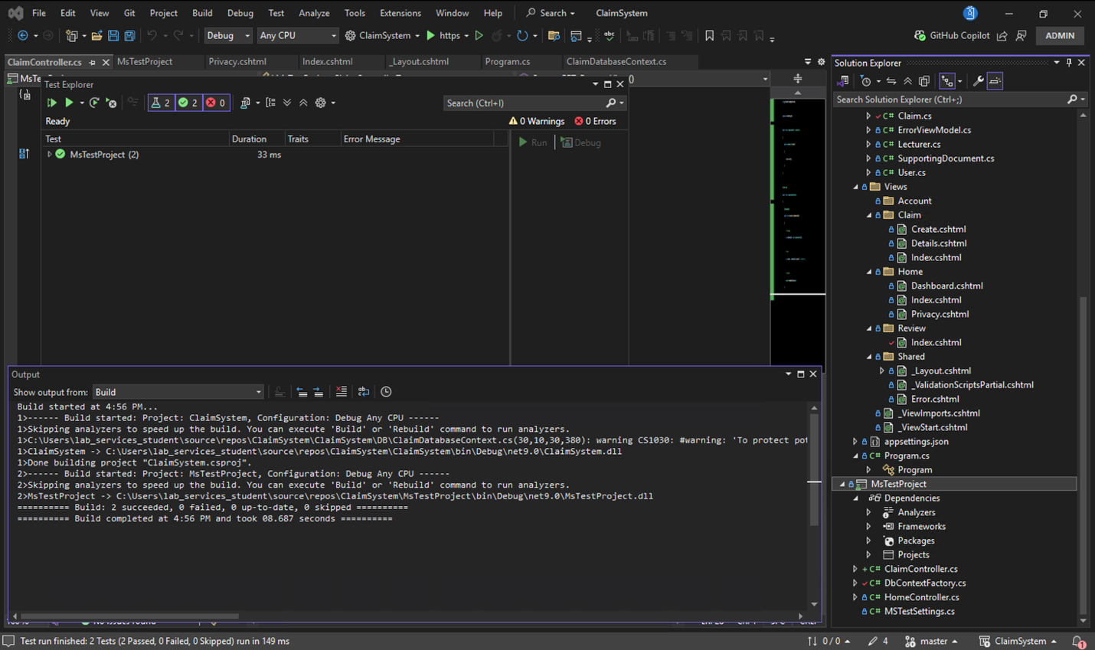

Review Controller Test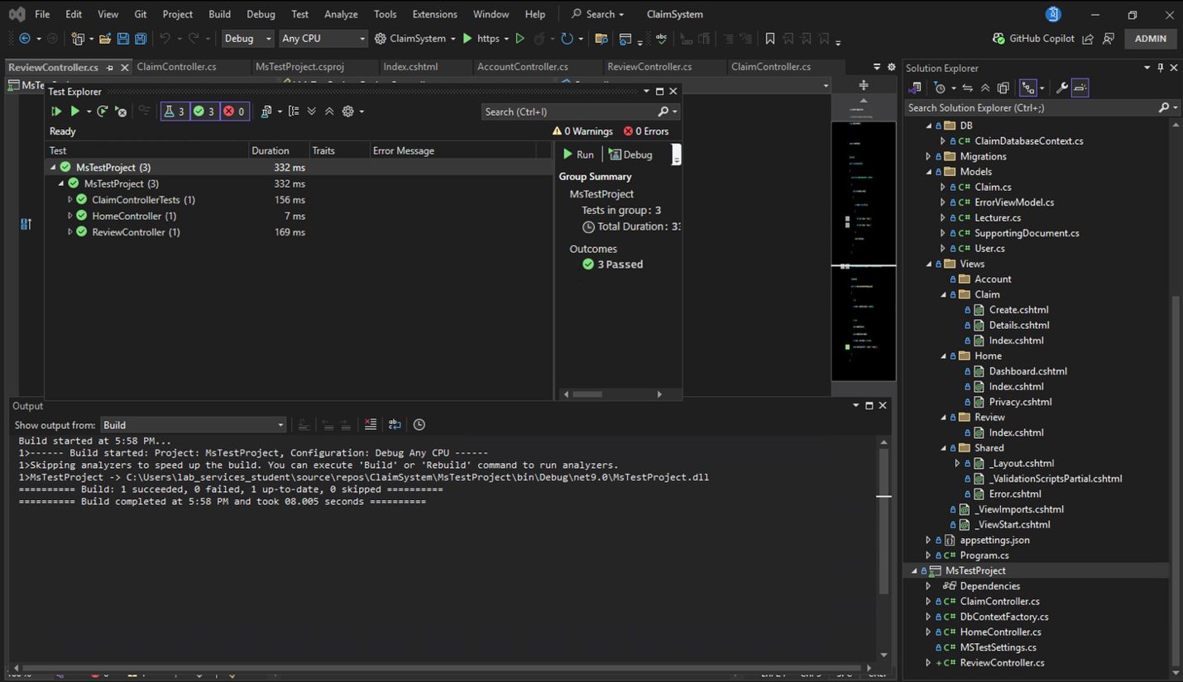

Home Controller Test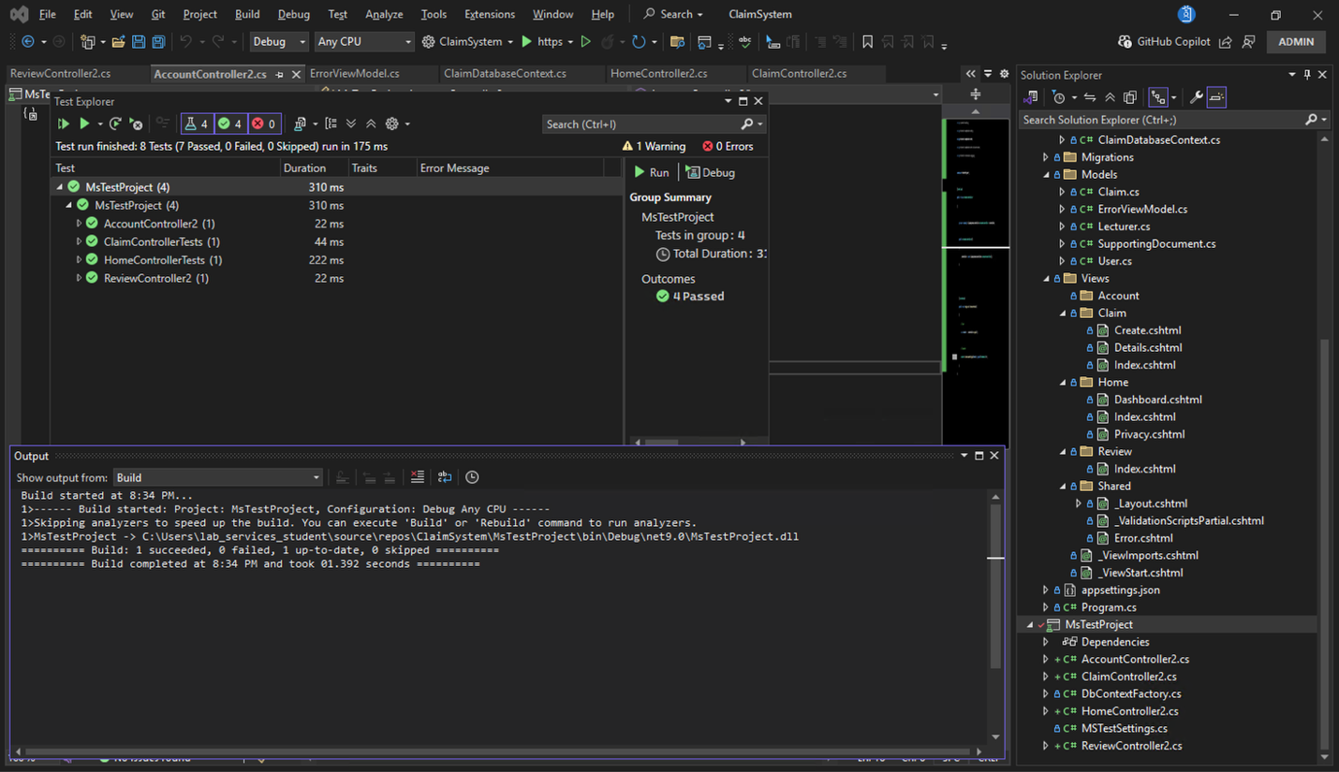

Account Controller Test

  - Feedback
Feedback for Design Choices and Structure = sorted out the entry hourly rate. The views of Coordinator and manager have been separated.
Feedback for UML Class Diagram for Databases: Accuracy and Completeness = I’ve eased down on methods.
Feedback for Version Control: Commit Frequency and Descriptive Messages = I’ve better worded my messages.

